Practical No:7
Aim: Develop simple calculator for addition, subtraction, multiplication and division operation using JavaScript.
Theory :
- JavaScript is a programming language used to create dynamic content for websites.
- It is a lightweight, cross-platform, and single-threaded programming language.
- It's an interpreted language that executes code line by line, providing more flexibility.
- Client Side: On the client side, JavaScript works along with HTML and CSS.
- HTML adds structure to a web page, CSS styles it, and JavaScript brings it to life by allowing users to interact with elements on the page, such as actions on clicking buttons, filling out forms, and showing animations.
- JavaScript on the client side is directly executed in the user's browser.

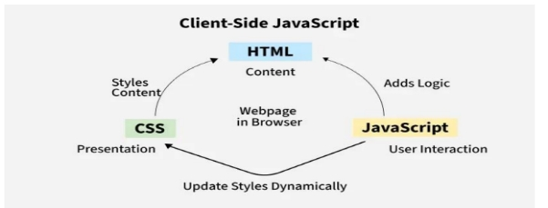

A calculator can be created using:
- HTML – To design the structure (buttons and input box)
- CSS – To style the calculator
- JavaScript – To perform calculations
JavaScript uses:
- function to define reusable code
- onclick event to perform actions
- parseFloat() to convert string into number

Program Code:
<!DOCTYPE html>
<html>
<head>
<title>Calculator</title>

<style>
body {
font-family: Arial;
background: linear-gradient(to right, #4facfe, #00f2fe);
display: flex;
justify-content: center;
align-items: center;
height: 100vh;
}

.calculator {
background: #fff;
padding: 20px;
border-radius: 10px;
width: 250px;
box-shadow: 0 4px 10px rgba(0,0,0,0.2);
}

#display {
width: 100%;
height: 50px;
font-size: 20px;
text-align: right;
margin-bottom: 10px;
padding: 5px;
border-radius: 5px;
border: 1px solid #ccc;
}

.btn {
width: 23%;
height: 50px;
margin: 1%;
font-size: 18px;
border: none;
border-radius: 5px;
cursor: pointer;
background: #4facfe;
color: white;
}

.btn:hover {
background: #007bff;
}

.equal {
width: 48%;
background: green;
}

.clear {
background: red;
}
</style>

</head>
<body>

<div class="calculator">
<input type="text" id="display" placeholder="Enter any values" readonly>

<div>
<button class="btn" onclick="press('1')">1</button>
<button class="btn" onclick="press('2')">2</button>
<button class="btn" onclick="press('3')">3</button>

<button class="btn" onclick="press('4')">4</button>
<button class="btn" onclick="press('5')">5</button>
<button class="btn" onclick="press('6')">6</button>

<button class="btn" onclick="press('7')">7</button>
<button class="btn" onclick="press('8')">8</button>
<button class="btn" onclick="press('9')">9</button>

<button class="btn" onclick="press('0')">0</button>
<button class="btn" onclick="press('.')">.</button>

<button class="btn" onclick="press('+')">+</button>
<button class="btn" onclick="press('-')">-</button>
<button class="btn" onclick="press('*')">*</button>
<button class="btn" onclick="press('/')">/</button>

<button class="btn clear" onclick="clearDisplay()">C</button>
<button class="btn equal" onclick="calculate()">=</button>
</div>
</div>

<script>
function press(val) {
document.getElementById("display").value += val;
}

function clearDisplay() {
document.getElementById("display").value = "";
}

function calculate() {
let exp = document.getElementById("display").value;
let result = eval(exp);
document.getElementById("display").value = result;
}
</script>

</body>
</html>

Conclusion:
The simple calculator was successfully developed using HTML, CSS, and JavaScript. It performs basic arithmetic operations such as addition, subtraction, multiplication, and division
Result:
The program executed successfully and displayed correct results for all arithmetic operations.

Output:-
